SQL FINAL PROJECT

1. Write a query to display the names (first_name, last_name) using alias name “First Name", "Last Name"

**Output:**

The output has total 107 rows.

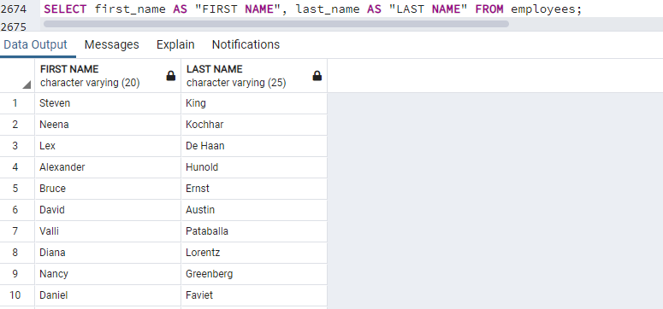

1. Write a query to get unique department ID from employee table.

**Output:**

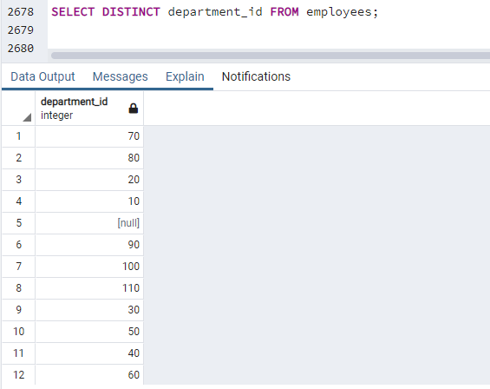

1. Write a query to get all employee details from the employee table order by first name, descending.

**Output:** Output consist of 107 rows.

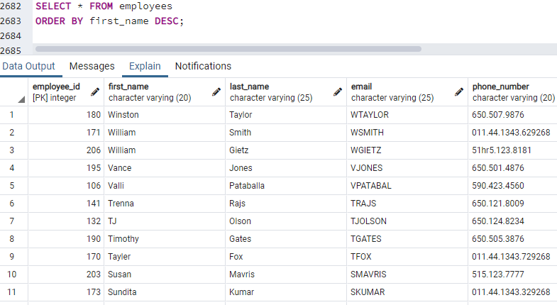

1. Write a query to get the names (first_name, last_name), salary, PF of all the employees (PF is calculated as 15% of salary)

**Output:**The output had 107 rows

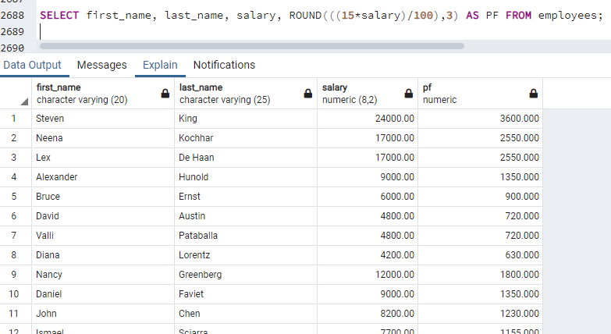

1. Write a query to get the employee ID, names (first_name, last_name), salary in ascending order of salary

**Output:**The output has 107 rows.

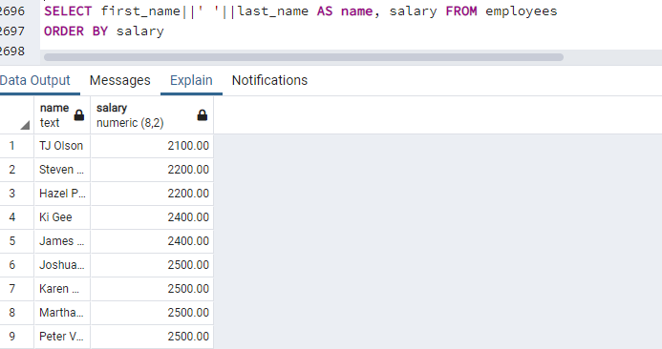

1. Write a query to get the total salaries payable to employees.

**Output:**

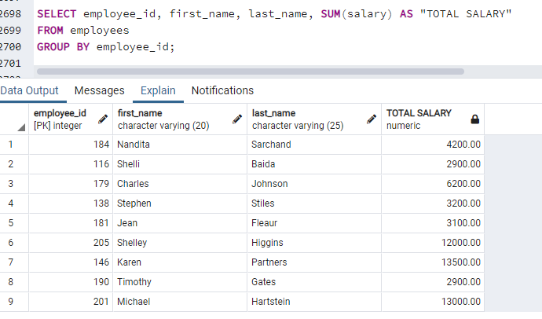

1. Write a query to get the maximum and minimum salary from employees table.

**Output:**

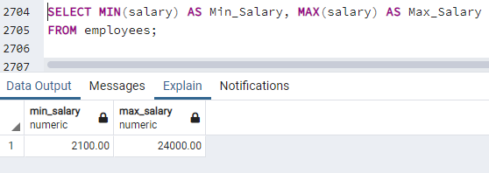

1. Write a query to get the average salary and number of employees in the employees table.

**Output:**

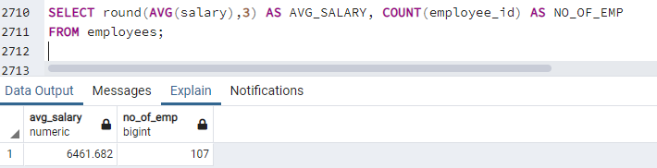

1. Write a query to get the number of employees working with the company

**Output:**

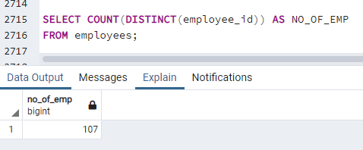

1. Write a query to get the number of jobs available in the employees table.

**Output:**

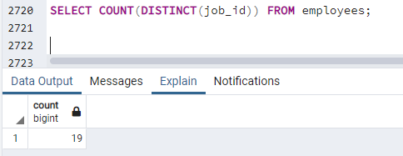

1. Write a query get all first name from employees table in upper case

**Output:**

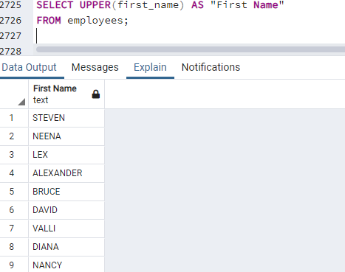

1. Write a query to get first name from employees table after removing white spaces from both side.

**Output:**

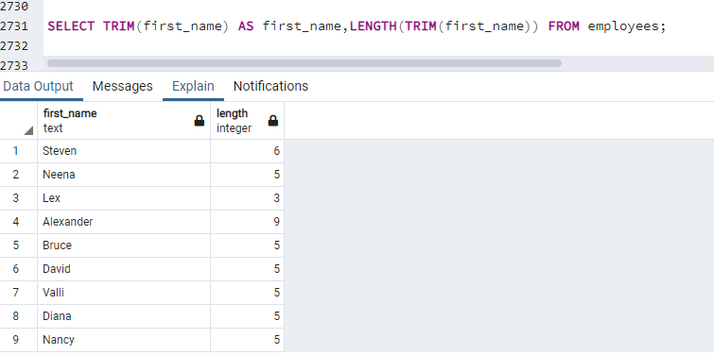

1. Write a query to get the length of the employee names (first_name, last_name) from employees table.

**Output:**

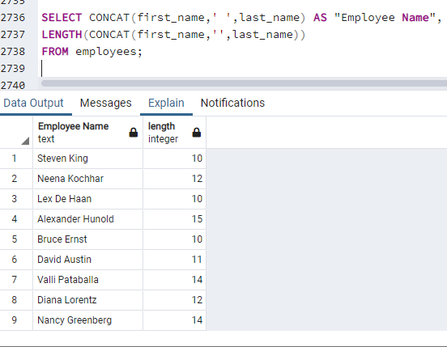

1. Write a query to display the name (first_name, last_name) and salary for all employees whose salary is not in the range $10,000 through $15,000.

**Output:**

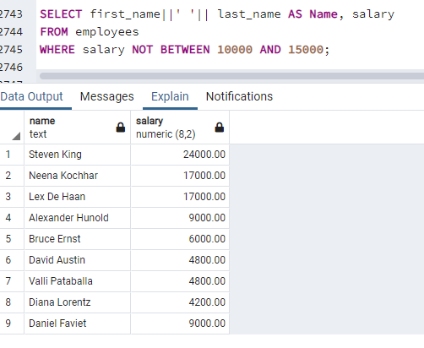

1. Write a query to display the name (first_name, last_name) and salary for all employees whose salary is not in the range $10,000 through $15,000 and are in department 30 or 100.

**Output:**

